Getting the New Software – Updated 4/10/25
Software Download Link for GVC1 Prime 9383 (Blue control board):
https://drive.google.com/file/d/1iq10RWywA5icQqFrHoeTnvCCUNpLQbiy/view?usp=sharing
Software Download Link for GVC2 Prime 13150 (Red control board):
https://drive.google.com/file/d/1eXj8UjMnhrVFDIq5-GFnXuu7AjK-bUiU/view?usp=sharing
- From the download links above choose either GVC1 Prime or GVC2 Prime based on your control board type.  - Download and save the file either to your Desktop or to your Downloads folder. | 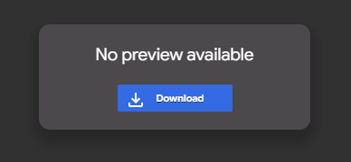
- Locate the downloaded file
- Rename the file to extension from “.bi_” to “.bin”
- Save the file to a USB drive  - The file must Not be in a folder. (the root) | 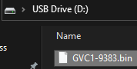

Programming the control board
Parts Needed
- USB Drive with software
- Jumper or coin to short programming pins

- Using the machines power switch turn the power off  - Locate USB port in the center of the control board | 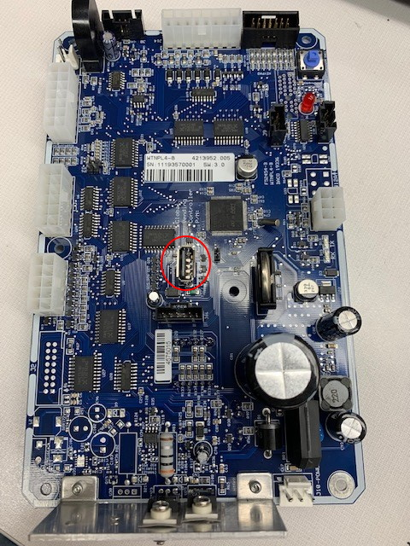
- Insert USB Drive in Port | 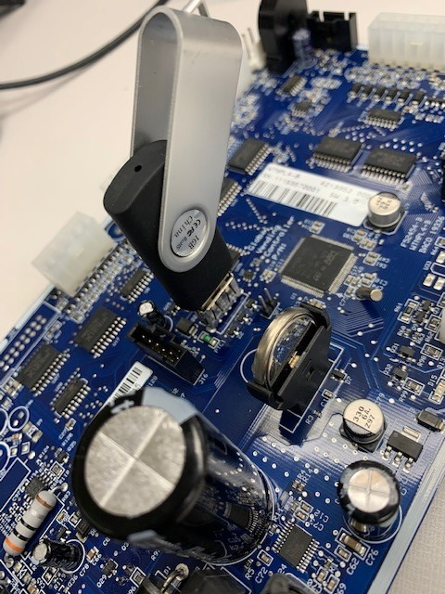
- Locate Programming Pins next to USB port. | 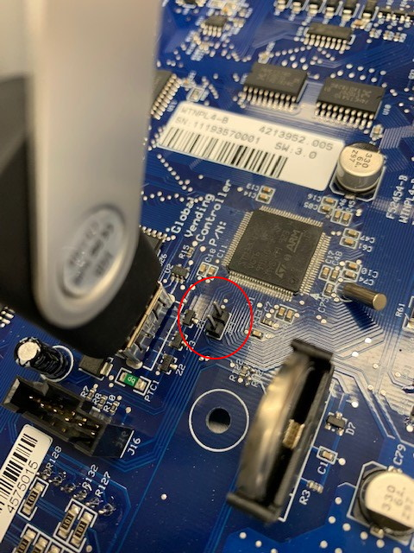
- Use jumper or a coin to short the Programming Pins together. | 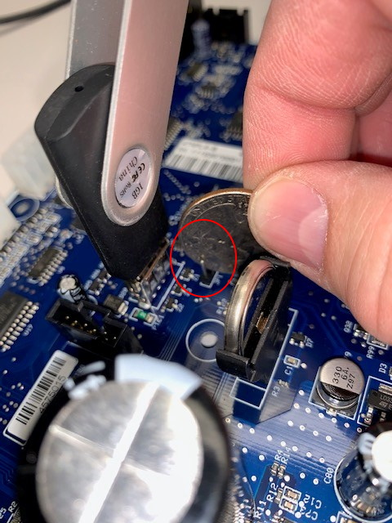
- With the jumper (or coin) still on the programming pins turn the power on to the machine.  - In the upper left-hand corner of the control board a light will rapidly flash while the board is programming.  - If the light flashes slowly, your USB drive is not compatible. Try a different USB drive.  - When the light has stopped flashing, programming is complete, turn the machine power off  - Remove USB drive and jumper or coin.  - Turn power on  - NOTE: Once you have programmed the control board, all setting returned to the factory default settings.  - Be sure to do a motor count, set prices and any other settings your machine may need such as, refrigeration, space to sales, etc. | 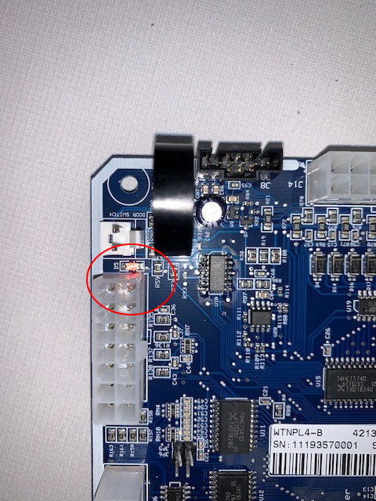

Link to video of programming process:
https://www.dropbox.com/s/zpfx9v888rz10yv/20210128_165703000_iOS.mp4?dl=0

