You have to remove the plate shown in picture below
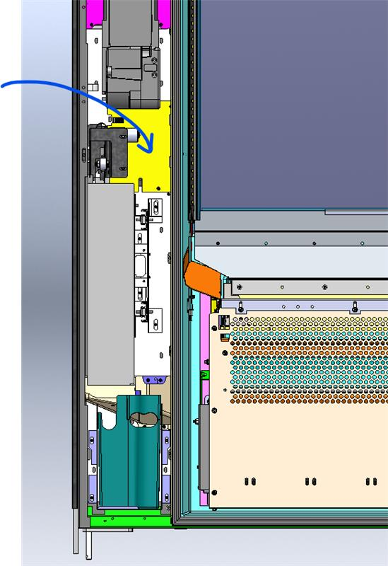

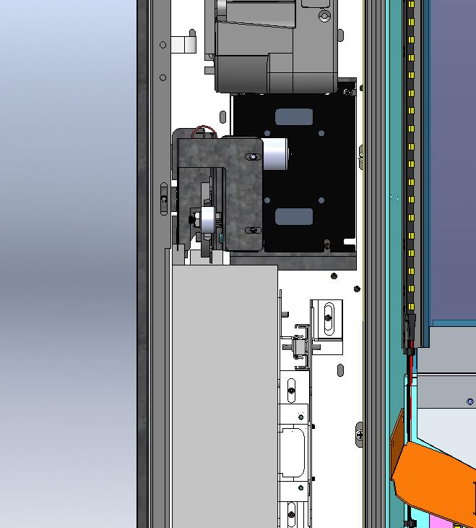

depending on bill validator (w/recycler) you may have to remove it for better access
you may have to remove this - coin return mechanism cover for better access

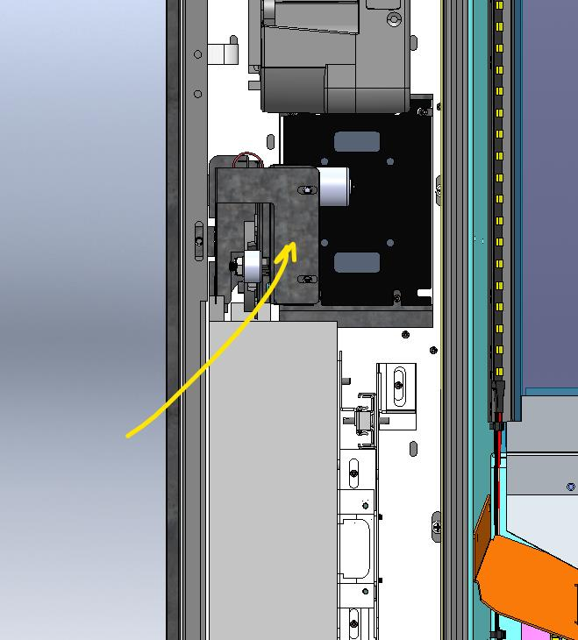

remove three screws

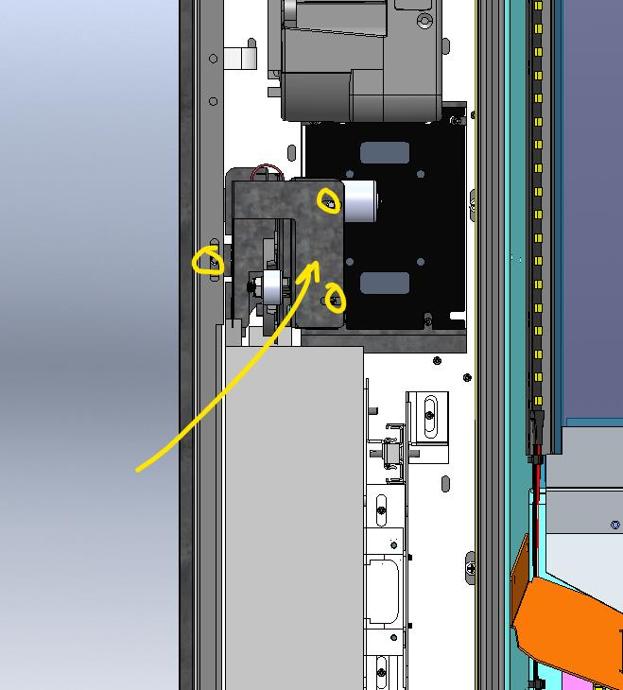
This will allow you access to the back of the card reader and or filler plate to remove and replace.

