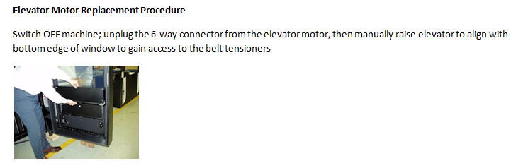
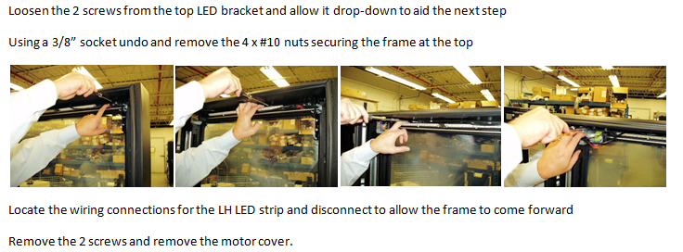
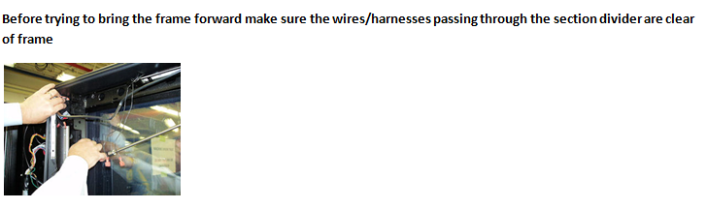
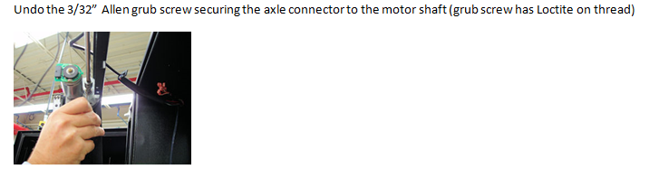
Later revisions also have an e- ring on the right side of the shaft that will need removed to allow drive axle to move away.
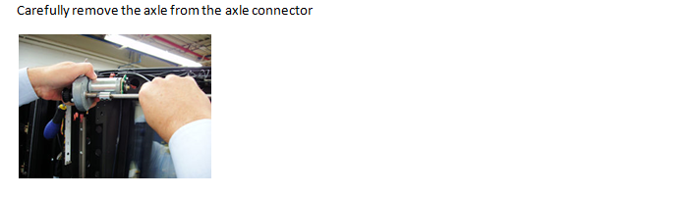
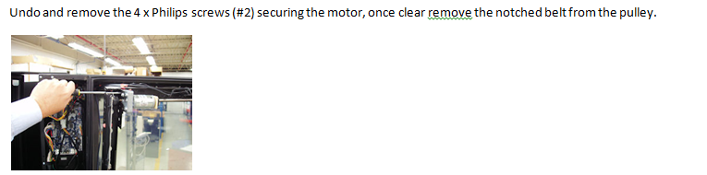
Replace the motor and reverse the above procedure to reassemble.

