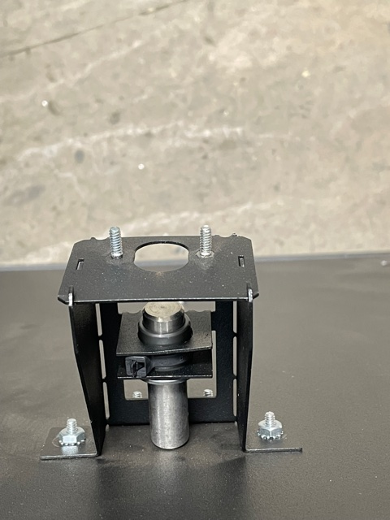
Step 2 – check to see that all 4 nuts w/star washers are tight securing drop sensor plunger to product delivery pan
Step 1 - check to see that the plastic tie is tight around drop sensor plunger sleeve

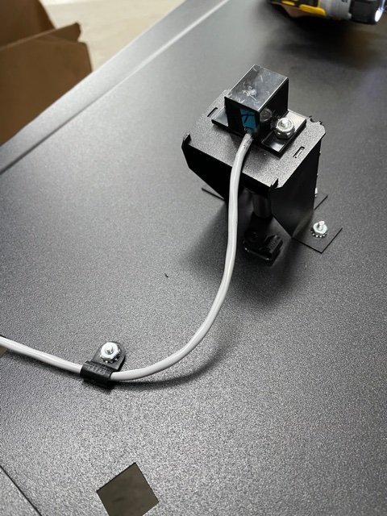
Step 4 – check to see that “P” clamp is securing sensor cable to product delivery pan
Step 3 – check to see that drop sensor is secured to plunger assembly
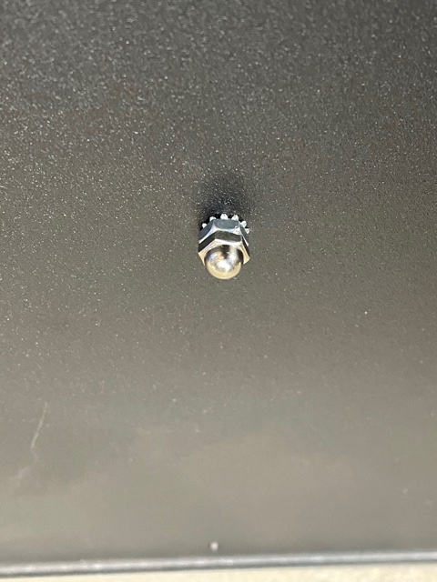

Step 5 – check to see that acorn nut is in place on bottom of product delivery pan. This will stabilize back of product delivery pan allowing proper sensing of product

